# Updatable Views in SQL

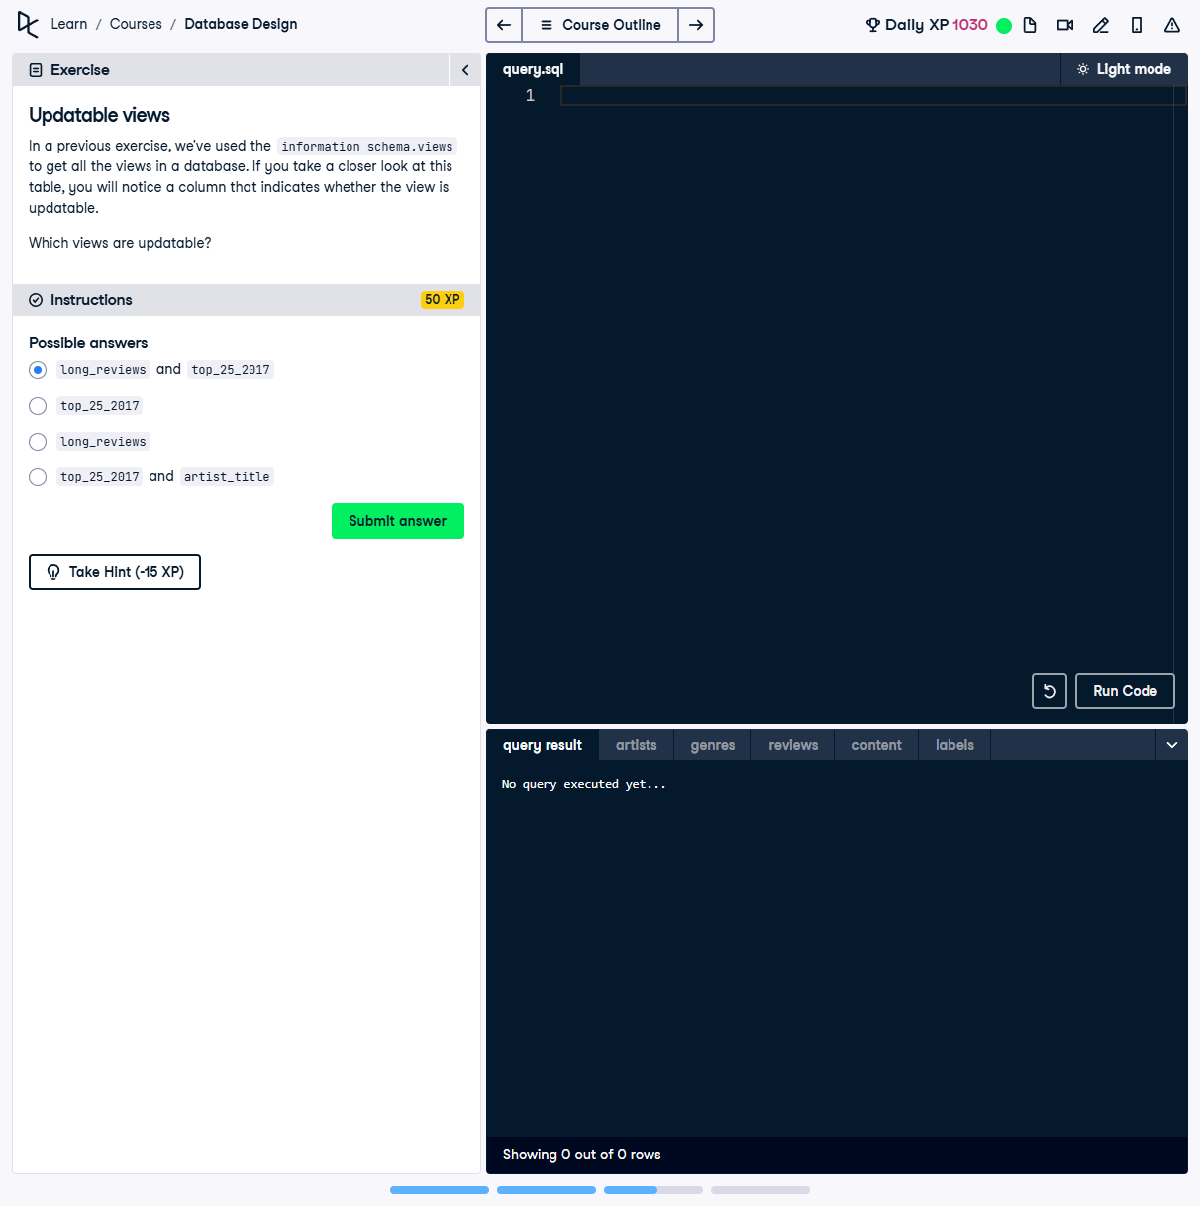

## Question:

In a previous exercise, we used the `information_schema.views` table to get all views in a database. This table contains a column indicating whether a view is updatable. Which views are updatable?

## Possible Answers:

1. `long_reviews` and `top_25_2017`

2. `top_25_2017`

3. `long_reviews`

4. `top_25_2017` and `artist_title`

## Correct Answer:

`long_reviews`

## Explanation of the Answer:

The correct answer is `long_reviews`. A view is updatable if it meets conditions such as being derived from a single base table and not using aggregate functions, GROUP BY, or complex joins. `long_reviews` satisfies these criteria, making it an updatable view.